**FIT INDIA MOVEMENT 2023**

Chandigarh College of Engineering and Technology (Degree Wing), Sector-26, organized events to celebrate FIT India Movement on 22 and 23 November 2023 as per letter no 8564 dated 16-11-2023 under the guidance of our honorable Principal - Dr. M.S. Gujral, Professor I/C Student Welfare Dr. Sunil K. Singh, President Student Council Dr. Gulshan Goyal and NSS Program Officer- Dr. Sarabjeet Singh

Dr Amit Chhabra and Dr. Sunita coordinated the event

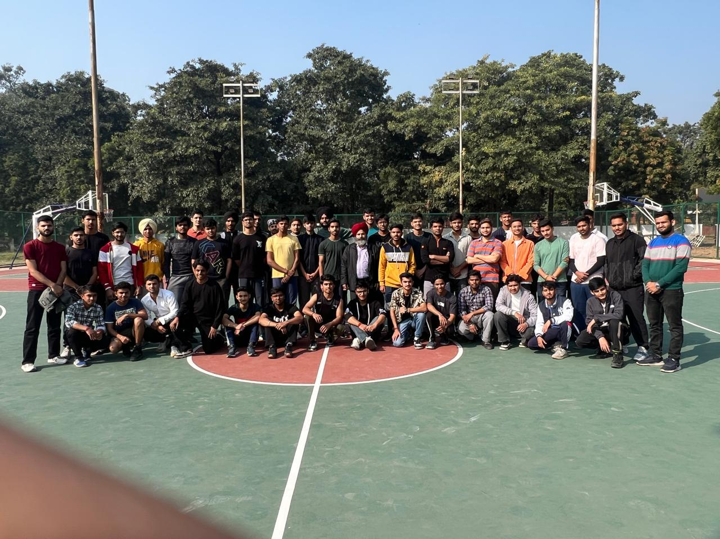

**PARTICIPATED TEAMS PHOTO: (BOYS TEAM)**

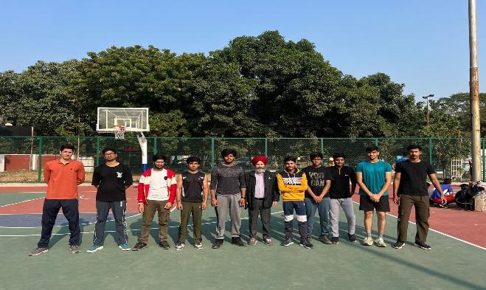 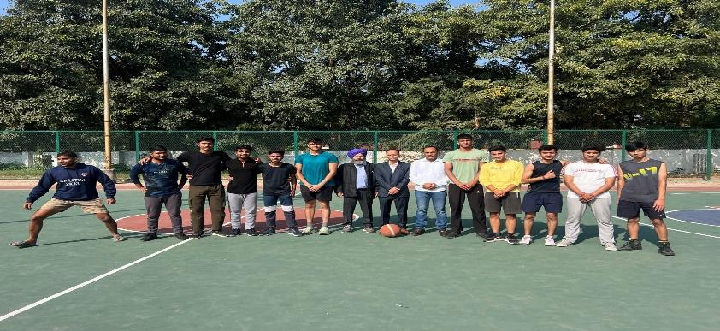

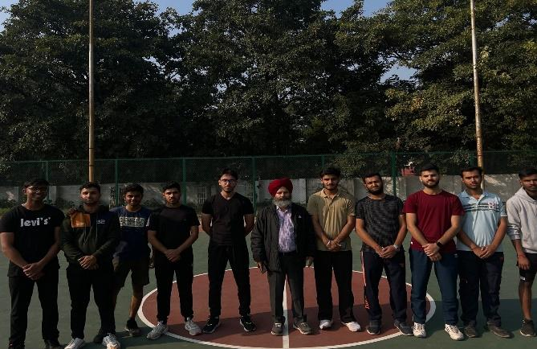 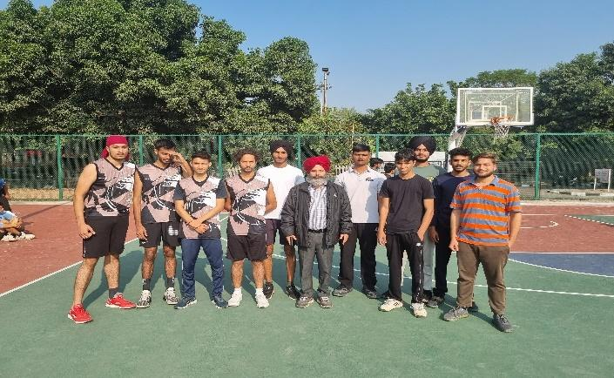

**STUDENT ORGANIZERS :**

1. **ROHIT KONDAL , MECH 4TH YEAR, CO20131**
2. **ANISH SHARMA , CSE 2nd YEAR , CO22308**
3. **MOHD ASHAD , CSE 2nd YEAR , CO22344**
4. **VIKAS , CSE 2nd YEAR , CO22375**
5. **SAHIL KONDAL , CSE 2nd YEAR , CO22359**

**PARTICIPATED TEAMS :**

**TEAM 1 - COMPLEX 26**

|  |  |  |  |
| --- | --- | --- | --- |
| **NAME** | **ROLL NO** | **BRANCH** | **YEAR** |
| SHUBHAM | CO23363 | CSE | 1st |
| ADITYA YADAV | CO21202 | CIVIL | 3rd |
| DEEPINDER SINGH | LCO21380 | CSE | 3rd |
| SUKHJOT SINGH | CO21565 | ECE | 3rd |
| ISHTVEER SINGH | CO21325 | CSE | 3rd |

**TEAM 2 – MECH PANTHONS**

|  |  |  |  |
| --- | --- | --- | --- |
| **NAME** | **ROLL NO** | **BRANCH** | **YEAR** |
| ROHAN | CO23146 | MECH | 1st |
| PRIYANSHU | CO23141 | MECH | 1st |
| KRISHNA | CO23128 | MECH | 1st |
| MANAV | CO23130 | MECH | 1st |
| DAKSHESH | CO23120 | MECH | 1st |

**TEAM 3- SASTE LAKERS**

|  |  |  |  |
| --- | --- | --- | --- |
| **NAME** | **ROLL NO** | **BRANCH** | **YEAR** |
| AKSHANSH SINGH | CO23308 | CSE | 1st |
| DEEPENDRA SINGH | CO23319 | CSE | 1st |
| CHETANYA | CO23318 | CSE | 1st |
| KRISH MADAAN | CO23339 | CSE | 1st |
| DEEPINDER SINGH | CO23320 | CSE | 1st |

**TEAM 4- CSE BITA**

|  |  |  |  |
| --- | --- | --- | --- |
| **NAME** | **ROLL NO** | **BRANCH** | **YEAR** |
| DEV KHATRI | CO23322 | CSE | 1st |
| YAKSH SHEORAN | CO23371 | CSE | 1st |
| VISHAL GAHLAWAT | CO23370 | CSE | 1st |
| AAYUSH SINGH | CO23305 | CSE | 1st |
| MRIDUL SHAILY | CO23346 | CSE | 1st |

**TEAM 5 – CIVIL SERVICES**

|  |  |  |  |
| --- | --- | --- | --- |
| **NAME** | **ROLL NO** | **BRANCH** | **YEAR** |
| ARYAN DEV SINGH RANA | CO23213 | CIVIL | 1st |
| PRAJANYA | CO23237 | CIVIL | 1st |
| ADITYA JARYAL | CO23204 | CIVIL | 1st |
| MAHIM | CO23230 | CIVIL | 1st |
| ABISHEK | CO23203 | CIVIL | 1st |

**TEAM 6 – ECE GANG**

|  |  |  |  |
| --- | --- | --- | --- |
| **NAME** | **ROLL NO** | **BRANCH** | **YEAR** |
| SAKSHAM KOHLI | CO22540 | ECE | 2nd |
| SHIVAM SINGH | CO22542 | ECE | 2nd |
| SANTOSH | CO22541 | ECE | 2nd |
| KANHIAYA | CO22525 | ECE | 2nd |
| HARSHIT | CO22521 | ECE | 2nd |

**TEAM 7 – DESTROYERS**

|  |  |  |  |
| --- | --- | --- | --- |
| **NAME** | **ROLL NO** | **BRANCH** | **YEAR** |
| YUGAM GUPTA | LCO215107 | ECE | 3rd |
| ROHIT | CO21559 | ECE | 2nd |
| PRESH | CO21553 | ECE | 3rd |
| SUKHJOT BATTH | CO21565 | ECE | 3rd |
| VAIBHAV | LCO215106 | ECE | 3rd |

**TEAM 8 – IMMORTAL KINGS**

|  |  |  |  |  |
| --- | --- | --- | --- | --- |
| **NAME** | **ROLL NO** | | **BRANCH** | **YEAR** |
| SAHIL KONDAL | CO22359 | | CSE | 2nd |
| MOHD ASHAD | CO22344 | | CSE | 2nd |
| ANISH SHARMA | CO22308 | | CSE | 2nd |
| VIKAS | CO22375 | | CSE | 2nd |
| ROHIT KONDAL | CO20131 | | MECH | 4rd |
| ATIKANT RAJPUT | CO20109 | MECH | | 4rd | |

**TEAM 9 – ECE AIR**

|  |  |  |  |
| --- | --- | --- | --- |
| **NAME** | **ROLL NO** | **BRANCH** | **YEAR** |
| Udit Bhatia | CO23560 | ECE | 1st |
| Alfsani Ahmad | CO23504 | ECE | 1st |
| Tanishq Bansal | CO23557 | ECE | 1st |
| TANISHQ SHARMA | CO23558 | ECE | 1st |
| ABHISAR | CO23501 | ECE | 1st |

**1st DAY MATCHES (knock out):**

**MATCH 1 : comples 26 vs mech pythons**

**WINNEING TEAM: comples 26**

**MATCH 2 : Destroyers vs ECE AIR**

**WINNING TEAM: Destroyers**

**MATCH 3: ECE GANG vs Saste Laykers**

**WINNING TEAM: ECE GANG**

**MATCH 4 : Immortal Kings vs Cse Bita**

**WINNING TEAM: Immortal Kings**

**MATCH 5 : God Hand vs Civil Services**

**WINNING TEAM: Civil Services**

**MATCH 6 : ECE GANG vs Civil Services**

**WINNING TEAM: ECE GANG**

**2nd DAY MATCHES (LEAGUE):**

**MATCH 1 : comples 26 vs ECE GANG**

**WINNING TEAM: comples 26**

**MATCH 2: Immortal Kings vs Destroyers**

**WINNING TEAM: Immortal Kings**

**FOR 1ST AND 2ND POSITION (FINALS)**

**MATCH 3 : comples 26 vs Immortal Kings**

**WINNING TEAM: comples 26**

**FOR 3RD POSITION(SEMI-FINALS)**

**MATCH 4 : ECE GANG vs Destroyers**

**WINNING TEAM: ECE GANG**

**WINNERS :**

**1st POSITION = comples 26**

|  |  |  |  |  |
| --- | --- | --- | --- | --- |
| **NAME** | **ROLL NO** | **BRANCH** | **YEAR** | **FATHERS’s NAME** |
| SHUBHAM | CO23363 | CSE | 1st | SAT PAL |
| ADITYA YADAV | CO21202 | CIVIL | 3rd | JASWANT SINGH |
| DEEPINDER SINGH | LCO21380 | CSE | 3rd | HARDEEP SINGH |
| SUKHJOT SINGH | CO21565 | ECE | 3rd | DEVINDER SINGH |
| ISHTVEER SINGH | CO21325 | CSE | 3rd | SUKHWINDER SINGH |

**2nd POSITION = Immortal Kings**

|  |  |  |  |  |
| --- | --- | --- | --- | --- |
| **NAME** | **ROLL NO** | **BRANCH** | **YEAR** | **FATHERS’s NAME** |
| SAHIL KONDAL | CO22359 | CSE | 2nd | SURESH KUMAR |
| MOHD ASHAD | CO22344 | CSE | 2nd | MOHD SHAMSAD KHAN |
| ANISH SHARMA | CO22308 | CSE | 2nd | NAVEEN KUMAR |
| VIKAS | CO22375 | CSE | 2nd | ASHOK KUMAR |
| ROHIT KONDAL | CO20131 | MECH | 4rd | SURESH KUMAR |
| ATIKANT RAJPUT | CO20109 | MECH | 4rd | ATMA RAM |

**3rd POSITION = ECE GANG**

|  |  |  |  |  |
| --- | --- | --- | --- | --- |
| **NAME** | **ROLL NO** | **BRANCH** | **YEAR** | **FATHERS’s NAME** |
| SAKSHAM KOHLI | CO22540 | ECE | 2nd | SANJEEV KOHLI |
| SHIVAM SINGH | CO22542 | ECE | 2nd | SUDHAKAR SINGH |
| SUDHAKAR YADAV | CO22548 | ECE | 2nd | MUNESHWAR YADAV |
| KANHIAYA | CO22525 | ECE | 2nd | RAKESH KUMAR |
| HARSHIT | CO22521 | ECE | 2nd | PRAVENDRA KUMAR |

**GIRLS TEAM**

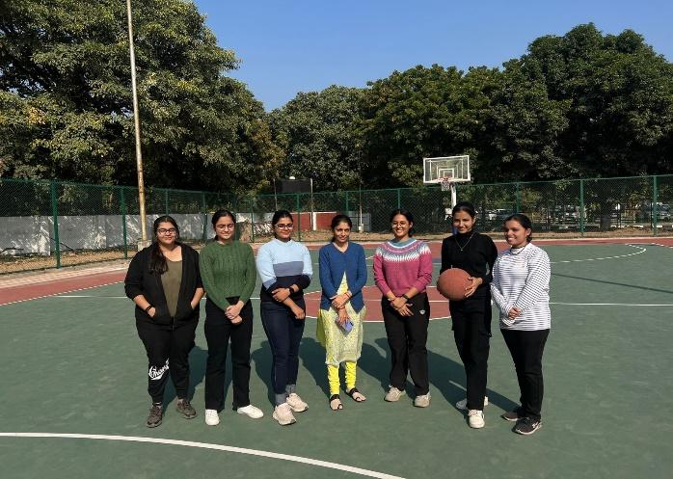 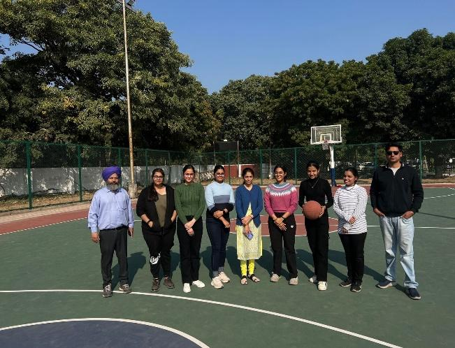

**PARTICIPATED TEAMS :**

**TEAM-1 Vixens**

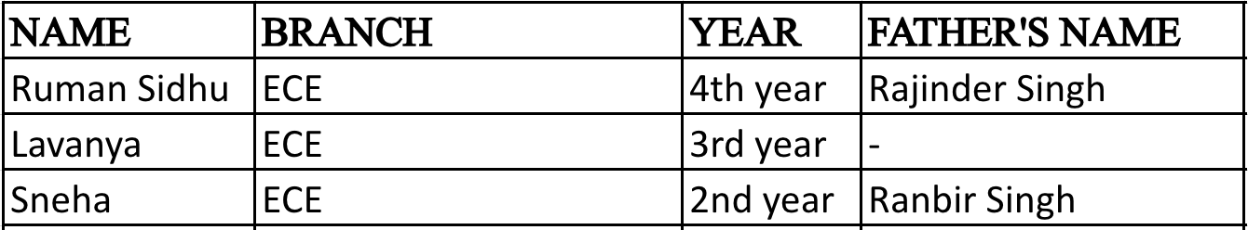

**TEAM-2 The Outlaws**

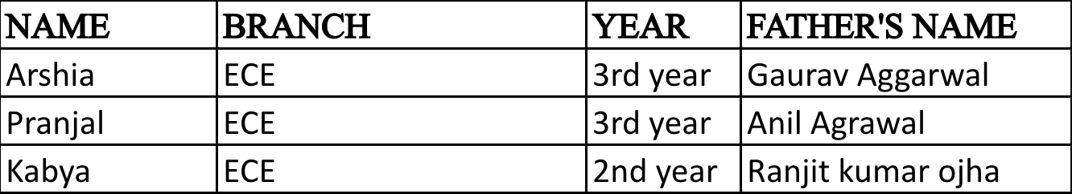

**WINNERS :**

**1st POSITION = VIXENS**

|  |  |  |  |
| --- | --- | --- | --- |
| **NAME** | **BRANCH** | **YEAR** | **FATHERS’s NAME** |
| RUMAN SIDHU | ECE | 4th | RAJINDER SINGH |
| LAVANYA | ECE | 3rd | - |
| SNEHA | ECE | 2nd | RANBIR SINGH |

**2nd POSITION = THE OUTLAWS**

|  |  |  |  |
| --- | --- | --- | --- |
| **NAME** | **BRANCH** | **YEAR** | **FATHERS’s NAME** |
| ARSHIA | ECE | 3rd | GAURAV AGGARWAL |
| PRANJAL | ECE | 3rd | ANIL AGGARWAL |
| KABYA | ECE | 2nd | RANJIT KUMAR OJHA |